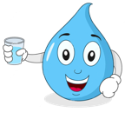
Cool Down:
Name
What’s in your water?

Directions: Answer the following questions about the activity.
- What changes did you observe in the water after filtration?

- Are there any pollutants that your filter system couldn’t remove? If so which ones.

- How does pollution affect the quality of the water in our community?

- Why isn’t the filtered water safe to drink yet?

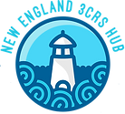


- How can we prevent pollution?
3CRS is supported by the National Science Foundation under EPSCoR RII Track-2 FEC: Community-Driven Coastal Climate Research & Solutions for the Resilience of New England Coastal Populations, Award #2316271.

