
Filter Design
Name
Directions: Use the water bottle outline below to draw the layers of materials you would include in your filtration device. Be creative and think about how each layer will help clean the water!
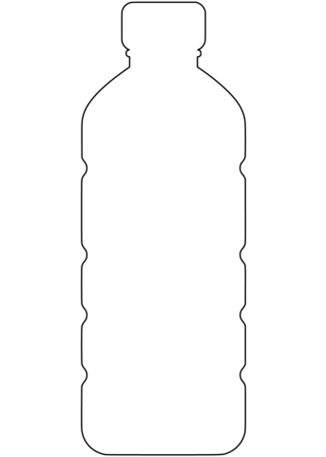



3CRS is supported by the National Science Foundation under EPSCoR RII Track-2 FEC: Community-Driven Coastal Climate Research & Solutions for the Resilience of New England Coastal Populations, Award #2316271.

