Waste Water Treatment – Filtration
Teachers Guide

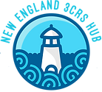

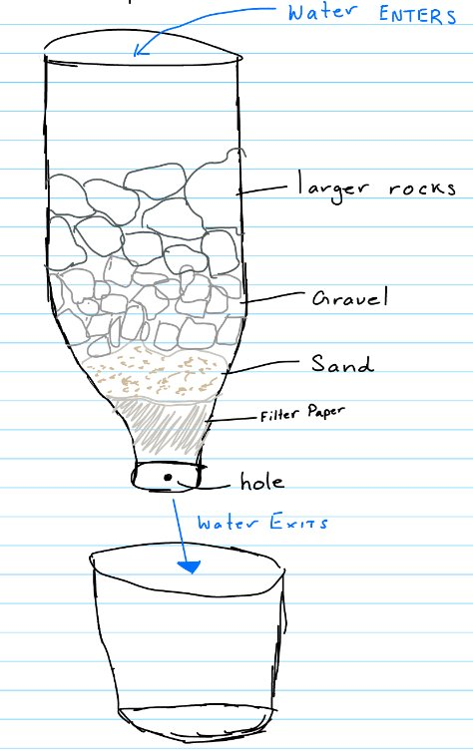
The lesson plan aims to engage fifth and sixth-grade students in understanding water pollution and its impact on their communities. Students will discuss real-life experiences with polluted waterways, raising awareness to the issue. They will then investigate the processes involved in producing safe drinking water, enhancing their knowledge on natural resources in the community. Finally, students will design, build, and test a water filtration system, applying their learning to create practical solutions.

This hands-on approach encourages critical thinking and promotes awareness of environmental issues and is suitable for community outreach initiatives.

3CRS is supported by the National Science Foundation under EPSCoR RII Track-2 FEC: Community-Driven Coastal Climate Research & Solutions for the Resilience of New England Coastal Populations, Award #2316271.



Next Generation Science Standards

Constructing explanations and Designing Solutions (5PS1 – 3) ​

Asking Questions and Defining Problems (MS – PS2 – 3) ​

Engineering Design (3 – 5 – ETS 1 – 2)
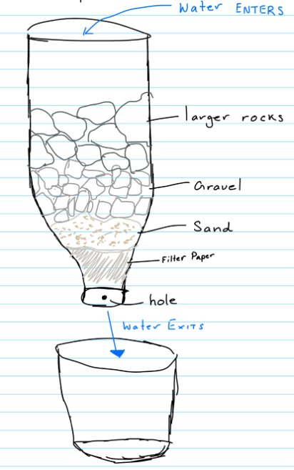
Materials
Following materials needed for individual set up:
- Clear water/soda bottles
- Scissors
- Coffee filter
- Cotton balls
- Sand
- Gravel
- Small rocks
- Clear cups

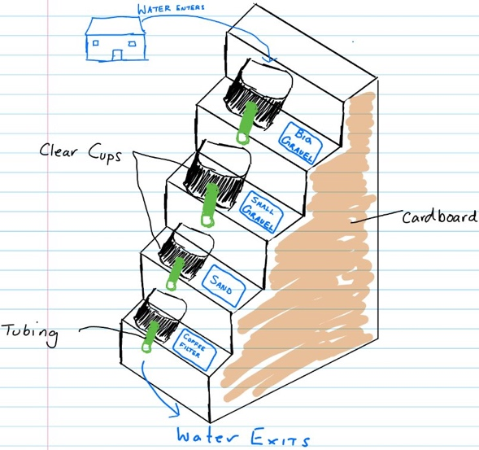

Following materials needed for group set up:
- Cardboard ​
- Colored papers​
- Small cups​
- Tubing​
- Plastic tray​
- Sand​
- Gravel​
- Tissue paper/cotton​
- Glue gun​

Following materials needed for a classroom demo:
- Large plastic bin​
- Garden soil​
- Clear tubing​
- Empty containers (for water tower, reservoir and house)​
- Gravel​
- Coffee filter​
- Scissors​
- Tape​

- Warm up
Provide students with a warm-up worksheet and encourage discussion about the different challenges communities encounter related to water pollution.

Tell students they will be investigating how water is contaminated and then cleaned for drinking.

Discussion Questions:
- Possible pollutants in Water (bacteria, trash, chemicals, sand, leaves)
- Student experiences with polluted waterways
- Sources of pollution (runoff, agricultural pollution, septic systems, littering)​
- Signs of poor water quality (sediment, cloudiness, odor)​
- How can we treat dirty water?
- What types of materials may assist us in removing large particles of debris from water.
- How often do we use water?

- Modern Water Treatment Facility
Describe the key steps in the process of treating water from a reservoir to make it clean and safe for everyday use at home.
- Storm water runoff flows into storm drains​
- Water accumulates in a reservoir ​
- Water flows from reservoir to water treatment facility through large pipes​
- Water is treated with chemicals to eliminate tiny organism ​
- Filters separate tiny particles from water​
- Filtered water is treated with more chemicals to make it safe to drink​
- Clean water flows into your tap and shower​

III. Design Filter by sketch
Students will work as engineers to design a filter device using household materials. Water bottle templates are provided in the student packet.
- Remind students of the materials available for todays experiment

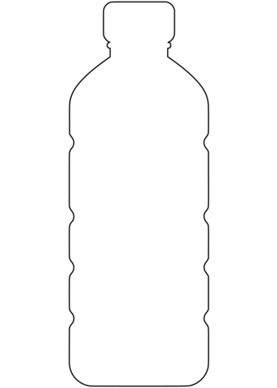

Pre - experimental Procedure:
- Prepare dirty enough dirty water for all students to test their filter at least two times.
- For each student carefully cut off about 1 inch from the bottom of a clear water/soda bottle using scissors. Place coffee filter flat on the cap side of the water bottle and secure with rubber band.
- Prepare 2 sample filter systems as examples for students
    - Fill prepared water bottle with equal amount of cotton balls followed by fine sand, small pebbles and large rocks
- Create a materials station

Classroom Procedure
- Begin by explaining the general purpose of today’s lab. Have students complete the warm-up worksheet to get started.
- Show the prepared dirty water sample and ask students if they think it’s safe to drink. Discuss factors contributing to water pollution in their community.
- Go over the general steps in the process of treating water from a reservoir to make it clean and safe for everyday use at home.
- Transition to the experiment by introducing the available materials and demonstrating how the sample filter devices work.
- Allow students to sketch and label their filter systems using the Water bottle template.
- Review and approve each filter design. Approved designs should include at least four equal layers of filtering materials.
- Allow students to fill out Part A of Student Data Worksheet
- Guide students as they test their filter system by pouring the dirty water sample into the open end of the water bottle
- Allow students to record observations of the water post filtration in Part B of Student Data Worksheet. Recording what pollutants were removed from the water.
- Provide instructions for proper disposal and cleaning of all materials used in the experiment
- After all students have tested their filters give them time to individually complete the Cool Down Worksheet.

