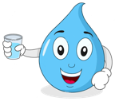
Student Data Sheet:
Name
What’s in your water?

Part A – Before Filtration
Describe the conditions of the dirty water before testing your filter device (color, smell, specific pollutants).

Part B – After Filtration
Describe the conditions of the dirty water after testing your filter device (color, smell, specific pollutants).




3CRS is supported by the National Science Foundation under EPSCoR RII Track-2 FEC: Community-Driven Coastal Climate Research & Solutions for the Resilience of New England Coastal Populations, Award #2316271.

